Tiny Tooshie
One-Size Diaper Pattern
By Angela @ Domestic Godliness
http://domestic-godliness.blogspot.com

LADIES, THIS IS THE EASIEST ONE-SIZE DIAPER TO MAKE AND IT IS ALSO THE LEAST EXPENSIVE ONE-SIZE DIAPER OUT THERE!!

GET READY TO HAVE SOME FUN, PROTECT OUR EARTH AND SAVE SOME DOUGH$$!!

This diaper fits most babies from 7lbs. to toilet training or 32 lbs.

NOTE: For success with this pattern, please read throught the entire pattern before beginning.

Materials:

Pattern Snap Fasteners Elastic (1/4 inch)
Scissors Thread Recycled Fabric/Material
Sewing Machine Velcro (optional)

Why Cloth?
The Lord has called us to be good stewards of all we have been given. Cloth diapering is just one more way we can do this. We do this by:
-Taking care of earth, our temporary home
-Being frugal with our money so that we can have more to give
Families who use cloth as opposed to disposables save, on average, over $2000.00 on diapering supplies PER CHILD. If you take care of your diapers (more on how to do this on page 2), you may even be able to use the same ones for multiple children. This could double or even triple your savings!

Why One-Size?
The answer is simple -You only have to buy diapers once!! Now, let’s crunch some numbers. A newborn goes through approx. 10-18 diapers per day. In this case you would like to have somewhere between 36-54 diapers depending on how often you want to launder. The number of diapers used in a day decreases as your child grows, but in most cases parents like to have at least a three day supply – so lets say on average you should have 35 diapers in each size (XS,S,M,L,XL). 35 diapers X 5 sizes = 175 diapers!!! Now, anyone can see how that starts to get expensive!! Clearly, using one-size diapers will save you on time and energy as well as enormously increase your monetary savings!

A Brief Comment on Materials:
There are 3 parts to my one-size cloth diaper– the outer layer, the inner layer (the part that comes in contact with your child’s skin), and the soaker pad. The layers can be made from (but not limited to) the following materials:
Non-Waterproof Fabrics
Cotton Flannel Any Materials in the Recycle Pile
Fleece Towel Material Any Material that is:
T-Shirt Old Jeans -highly absorbent (for soaker pad) -gentle on baby’s skin (for inner layer)
Waterproof/Water-Resistant Fabrics
PUL Old Swim Trunks
Vinyl Tablecloth Material Any Recycled Waterproof Material

Of course there is always the option of purchasing new items, but please note that this will cost more $$ than what was previously stated.

I believe that one of the greatest benefits to cloth diapering is affordability. When I first started cloth diapering, I went out and spent quite a bit of money on cloth diapers and later realized that this was not necessary. One-size cloth diapers range from $18-$35 each. By following my pattern you will only be spending $.50cents-$2 on each diaper. This means you will be able to afford more diapers and we all know what this means – LESS LAUNDRY!!!
Before you begin –
You first must decide if you want the outer layer to be waterproof or not. If you use a waterproof outer fabric, you will not need a diaper cover. If you use non-waterproof fabric, you will want to either make separate diaper covers or purchase diaper covers. If you should decide to make diaper covers separately, please keep in mind that you will need to make them one-size also or they will not fit over the one-size diaper. In this case it would be more cost effective to just make a waterproof outer layer. This way you will be using half the amount of elastic and snap fasteners that would be required. If you purchase waterproof diaper covers in the store, keep in mind that you will need to buy different sizes as your child grows.

Now on to the pattern!

With this file you should have received 4 pattern pages: Diaper 1, Diaper 2, Diaper 3 & Diaper 4. Print out all 4 pattern pages.

Align Diaper 1, 2 and 3 patterns and secure together. Diaper 4 pattern will be used separate from the other 3.

Making the Outer and Inner Layers:
1.) Pin Diaper 1, 2 & 3 pattern (which should be aligned and attached) onto desired fabric, making sure that the fabric fold meets up with the place marked “FOLD” on Diaper 2.
2.) Cut.
3.) Repeat this step for both the inner fabric and the outer fabric.

Attaching the Snap Fasteners:
1.) On the outer fabric only, attach snap fasteners in spaces designated on the pattern. You can do this by using a washable sewing marker to mark where the fasteners will go and by following the directions on the fastener package to attach. The top row of fasteners will be “male” snaps and the two bottom rows will be “female.” This will make it possible for you to adjust your diaper’s length (S< M< L) as your child grows.

Cutting the Elastic:
1.) Cut one piece of elastic for the back side of the diaper (this will be used on the back half of the baby’s waistline). Do not stretch while cutting. The pattern will ask that you double the length drawn on the pattern. Placing elastic here will prevent explosions out the back!
2.) Cut 2 pieces of elastic for the inner legs. Do not stretch while cutting. The length is designated on Diaper 4 pattern. Do not double as you did with the back side piece of elastic.

Last Minute Touches:
1.) Decide which side will be the bask side (along the back half of your baby’s waistline) of both the inner and outer fabric pieces. There will be an opening in the back side where you can slip in soaker pads to meet your baby’s absorbency needs. Fold 1/8 inch over edge of inner fabric and press; fold 1/8 inch over again and press. Pin. Stitch across to make a clean edge for opening that will not ravel when washed.
2.) Do the same for the outer fabric, except on this piece sew the elastic in. You can do this by pinning the end of the elastic where you want it to go and then by pulling each end as you run it through your sewing machine. You must stitch over the elastic and make sure that the elastic piece is fully stretched from end to end of backside while sewing. This will create the tight fit that you need. The folds will create a “casing” for the elastic.

Putting it all Together:
1.) Lay fabric, right sides facing each other and backsides together, and pin the two fabrics together as well as the two layers of fabric and the inner thigh elastic along each inner thigh. Be sure that the elastic is stretched fully out from end to end while sewing. Again, you can do this by pinning the end of the elastic where you want them to go and then by pulling each end as you run it through your sewing machine. Again, you must be sure to stitch over the elastic to provide the tight fit around the leg.
2.) Stitch around the entire diaper EXCEPT the back side. You can leave the length shown on the top of Diaper 2 open. You have already finished these edges and this will make a “pocket” for your soaker pads.

CONGRATULATIONS!
You’ve made it through the toughest part!
Now on to making the soaker pads!

Making Soaker Pads:
1.) Using Diaper 4 pattern, place fabric fold along bottom edge as written on pattern and cut.
*I recommend using fleece for soakers because fleece does not ravel. This means you won’t have to do any stitching on the soakers!! If you use another fabric besides fleece, it will need to be highly absorbent (like an old towel) and you may need to double the fabric to make it an absorbent enough soaker. In either case, if you are using a fabric that ravels, you will need to sew around the outside to prevent fraying. At nighttime you may want to use 2 or 3 pads depending on the thickness and absorbency level of your soakers.

YOU ARE FINISHED!!
NOW WASN’T THAT EASY?

Velcro Option
I have found that the most economical way to fasten the waistline of Tiny Tooshies is to use diaper pins. Velcro is also an option. Simply stitch Velcro along the waistline of the diaper so that you can adjust the width that way. You can also try “snappies,” which you can find online.

How to Use Tiny Tooshies
- Adjust the length of the diaper using the front snaps
- Place the soaker pad inside the diaper
- Fasten the width of the diaper along your baby’s waist with pins, Velcro or snappies.

Caring For Your Diapers
Use only water and detergent.
Wash in hot water.
Do not use detergents that include scents or other ingredients that could irritate your child’s bottom.
Do not soak diapers.
Rinse solid stools into toilet using the old fashioned method or a diaper sprayer, which can be purchased online for around $20.
Any stools or urine that are water soluble do not need to be rinsed prior to washing.
Place in dry pail or bag until ready to wash.

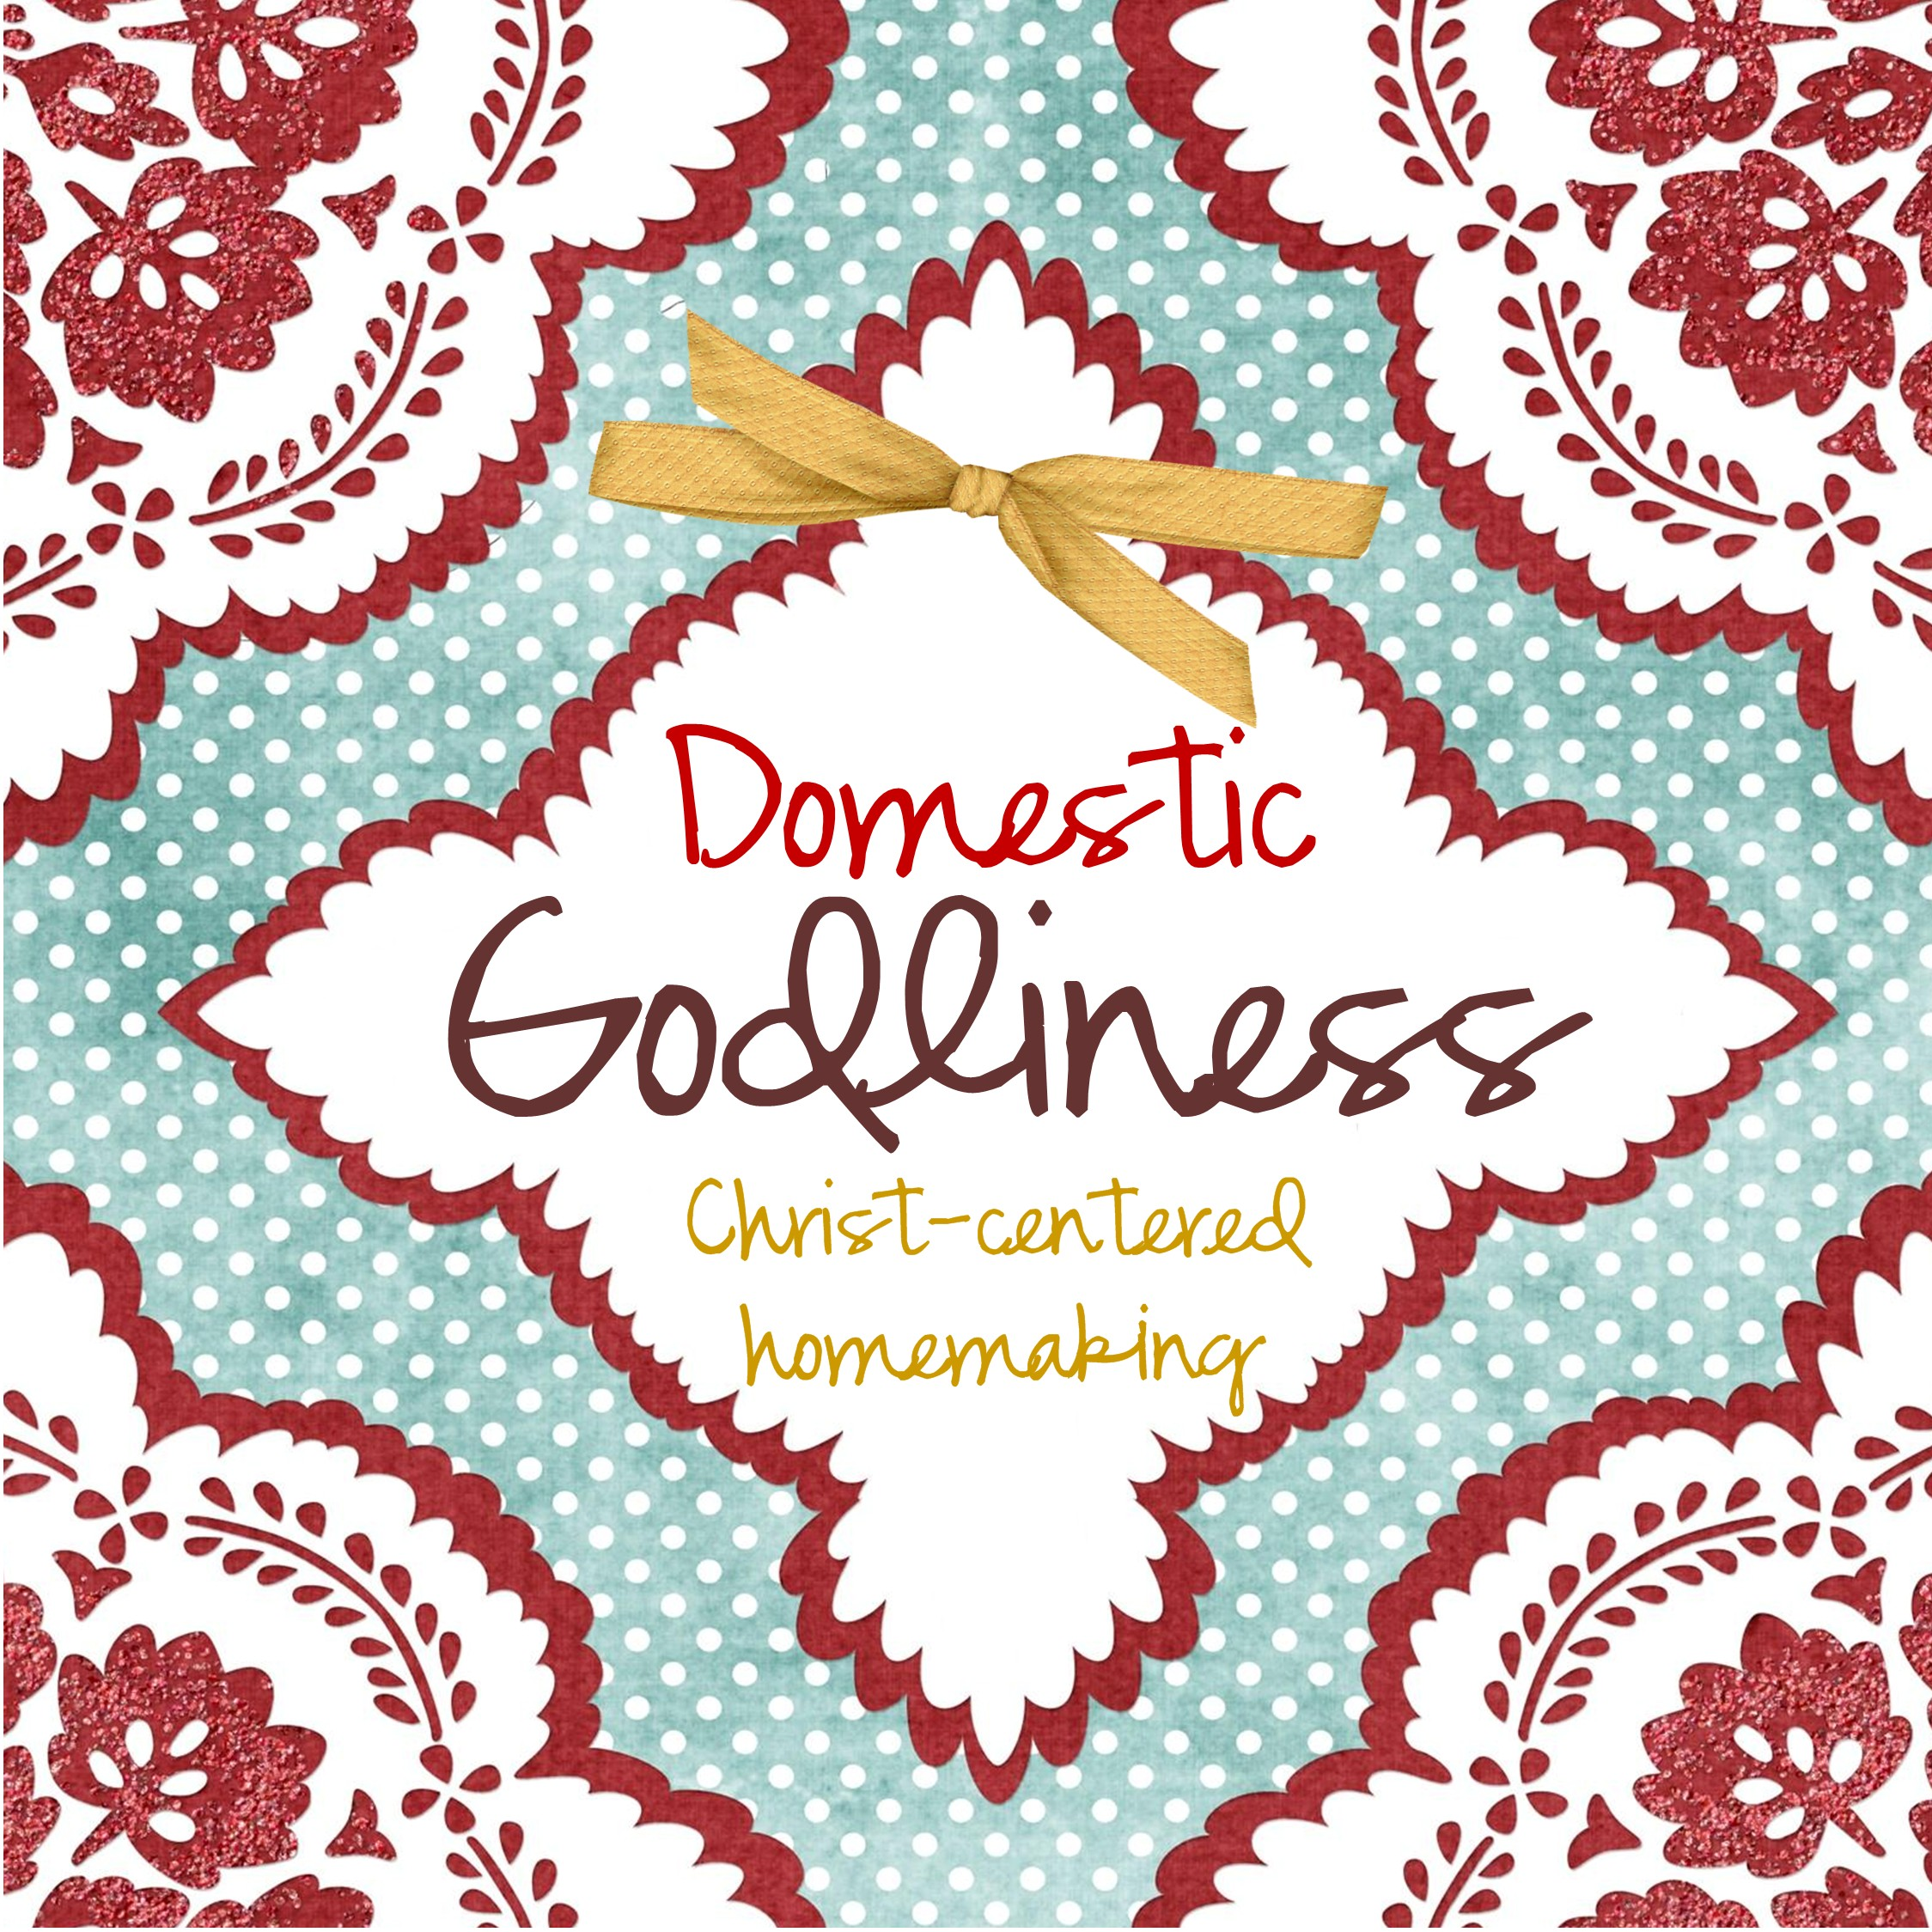

If you have any questions, please feel free to contact me on my blog - Domestic Godliness (http://domestic-godliness.blogspot.com)

Also, check out my blog for a “recipe” for homemade wipes to use with your cloth diapers.

*Copyright Domestic Godliness. This pattern is for personal use only. Not for resale.

